Statistical Inference Course Project - Part 2

Jón Guttesen

15 mai 2017

## Part 2 - The inferential analysis

#### 1. The ToothGrowth data and some basic exploratory data analyses

Tooth growth is The response is the length of odontoblasts (cells responsible for tooth growth) in 60 guinea pigs. Each animal received one of three dose levels of vitamin C (0.5, 1, and 2 mg/day) by one of two delivery methods, (orange juice or ascorbic acid (a form of vitamin C and coded as VC).

library(ggplot2)  
library(datasets)  
data(ToothGrowth)  
# cast dose as factor  
ToothGrowth$dose <- as.factor(ToothGrowth$dose)  
# show summary of data  
summary(ToothGrowth)

## len supp dose   
## Min. : 4.20 OJ:30 0.5:20   
## 1st Qu.:13.07 VC:30 1 :20   
## Median :19.25 2 :20   
## Mean :18.81   
## 3rd Qu.:25.27   
## Max. :33.90

#### 2. A basic summary of the data

g <- ggplot(ToothGrowth, aes(x = dose, y = len)) + geom_boxplot(aes(fill=supp))  
g

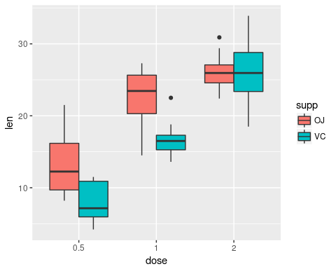 The plot shows that an increase in length as a result of higher dosages. Furthermore for doses 0.5 and 1 the plot shows an increase in length where dose is given as OJ vs VC. ### 3. Confidence intervals and hypothesis tests of a comparison of tooth growth by supp and by dose. First the effect of increasing the dosage will be examined. A two sample T test will be performed on length as a result of a dosage of 0.5mg versus dosage of 1.0mg. The same test will be performed on a of dosage 1.0mg versus a dosage of 2.0mg. Secondly the effect of the type of supplement will be examined. For each of the dosage levels, a two sample T test will be performed on lenght as a result of supplement type.

dtest1 <- t.test( len ~ dose, data = dplyr::filter(ToothGrowth, dose == 0.5 | dose == 1 ), paired = FALSE, var.equal = FALSE, conf.level = 0.95)  
dtest2 <- t.test( len ~ dose, data = dplyr::filter(ToothGrowth, dose == 1 | dose == 2 ), paired = FALSE, var.equal = FALSE, conf.level = 0.95)  
dtest1$p.value

## [1] 1.268301e-07

dtest1$conf.int

## [1] -11.983781 -6.276219  
## attr(,"conf.level")  
## [1] 0.95

dtest2$p.value

## [1] 1.90643e-05

dtest2$conf.int

## [1] -8.996481 -3.733519  
## attr(,"conf.level")  
## [1] 0.95

The results are as follows:

* dtest1, increasing dosage from 0.5 to 1.0 mg. Acceptably small p-value < 0.05, confidence intervals dont cross zero.
* dtest2, increasing dosage from 1.0 to 2.0 mg. Acceptably small p-value < 0.05, confidence intervals dont cross zero.

dtest0.5 <- t.test( len ~ supp, data = dplyr::filter(ToothGrowth, dose == 0.5), paired = FALSE, var.equal = FALSE, conf.level = 0.95 )  
dtest1.0 <- t.test( len ~ supp, data = dplyr::filter(ToothGrowth, dose == 1), paired = FALSE, var.equal = FALSE, conf.level = 0.95 )  
dtest2.0 <- t.test( len ~ supp, data = dplyr::filter(ToothGrowth, dose == 2), paired = FALSE, var.equal = FALSE, conf.level = 0.95 )  
dtest0.5$p.value

## [1] 0.006358607

dtest0.5$conf.int

## [1] 1.719057 8.780943  
## attr(,"conf.level")  
## [1] 0.95

dtest1.0$p.value

## [1] 0.001038376

dtest1.0$conf.int

## [1] 2.802148 9.057852  
## attr(,"conf.level")  
## [1] 0.95

dtest2.0$p.value

## [1] 0.9638516

dtest2.0$conf.int

## [1] -3.79807 3.63807  
## attr(,"conf.level")  
## [1] 0.95

The results are as follows:

* dtest0.5, supplement type at 0.5 mg. Acceptably small p-value < 0.05, confidence intervals do not cross zero.
* dtest1.0, supplement type at 1.0 mg. Acceptably small p-value < 0.05, confidence intervals do not cross zero.
* dtest2.0, supplement type at 2.0 mg. Unacceptably large p-value < 0.05, confidence intervals cross zero.

### 4. Conclusions and assumptions

Assumptions

1. As the plot shown in section 1 indicates, the variance of the samples are not equal. The T test with un-pooled variance was therefore used.
2. From the description of the dataset, the samples appear to be independent. The un-paired T test was therefore used.

Conclusions

1. With regards to the effect of each the supplement type, no effect of significance is found.
2. With regards to the effect of dosage level for dosages 0.5 and 1 a significant effect on lenght is optained.